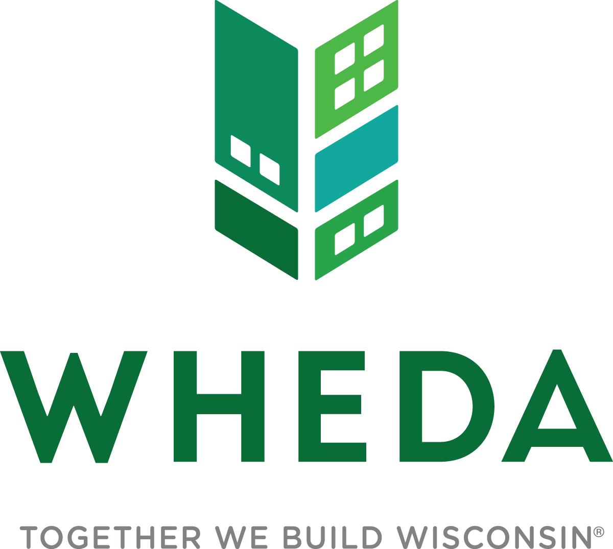

Inaugural Wisconsin Tribal Supportive Housing Institute Application

Due to: wisconsin.institute@csh.org

Due date: Monday, May 1, 202
CSH and the Wisconsin Housing and Economic Development Authority (WHEDA) are pleased to offer the first-ever Wisconsin Tribal Supportive Housing Institute (Tribal Institute) beginning in May 2023. The goal of the institute is to increase capacity within tribal communities to develop supportive housing, both on and off tribal land in Wisconsin, and to reduce the timeline for building supportive housing by improving the planning and development process.
Supportive housing combines affordable housing with services, and prioritizes households facing multiple barriers to housing stability, including those whose heads of household are experiencing homelessness; at risk of homelessness; or are staying in an institution because they have no other option; experiencing employment challenges; exiting other systems such as child welfare and justice; living with mental illness, substance use, and/or other disabling or chronic health conditions; and most impacted by structural and institutional racism.

Housing is critical to the health and wellness of individuals. By connecting affordable housing with supportive services, WHEDA and CSH aim to create lasting benefits for Native communities statewide. According to the CSH supportive housing needs assessment, Wisconsin needs 13,429 more supportive housing units to meet the needs of communities across the State. Data also shows that the Native population in Wisconsin is 4.5 times more likely to experience chronic homelessness and 6.6 times more likely to experience family homelessness compared to all other groups.

CSH has delivered the Supportive Housing Institute in communities across the country. CSH has hired a Wisconsin-based consultant to help adapt the Tribal Institute to reflect Indigenous culture and traditions and consider the nuances of tribal sovereignty and funding streams.

The Tribal Institute will provide 11 teams consisting of developers, social service providers, property managers, other key tribal staff, and non-Native allies with free technical assistance and training to take a supportive housing development from an idea to reality. The institute will be held over six months with training each month being held in-person or virtually. The institute will also position each team to prepare for competitive funding opportunities at differing funding entities.

Native housing professionals, non-Native allies, and community stakeholders interested in developing supportive housing are strongly encouraged to apply to this free resource.

The Tribal Institute is made possible by the
Wisconsin Housing and Economic Development Authority (WHEDA)

ABOUT CSH

CSH has been the national leader in supportive housing for over 25 years. CSH has worked in 47 states to help create stable, permanent homes for individuals and families. This housing has transformed the lives of over 200,000 people who once lived in abject poverty, on our streets or in institutions. A nonprofit Community Development Financial Institution (CDFI), CSH has earned a reputation as a highly effective, financially stable organization with strong partnerships across government, community organizations, foundations, and financial institutions. Our loans and grants totaling over $600 MM have been instrumental in developing supportive housing in every corner of the country, including helping to jumpstart the creation of over 200 supportive housing units on and off tribal reservation land in Minnesota starting in the early 2000s. Through its resources and knowledge, CSH is advancing innovative solutions that use housing as a platform for services to improve lives, maximize public resources, build healthy communities and break the cycle of intergenerational poverty. Visit us at csh.org to learn more.

ABOUT WHEDA
For 50 years, WHEDA has worked to provide low-cost financing for housing and small business development in Wisconsin. Since 1972, WHEDA has financed more than 87,000 affordable rental units, helped more than 138,300 families purchase a home, and provided more than 29,200 small business and agricultural loan guarantees. WHEDA is a self-supporting public corporation that receives no tax dollars for its operations. For more information on WHEDA programs, visit wheda.com or call 800-334-6873.

INSTITUTE OVERVIEW
CSH’s premiere workshop experience, the Supportive Housing Institute, helps teams navigate the complex process of developing housing with supportive services to prevent and end homelessness.

The Wisconsin Tribal Supportive Housing Institute will provide 11 teams made up of developers, social service providers, property managers, and other key tribal staff and non-Native allies with technical assistance and training to take a supportive housing development from an idea to reality. The institute will be held over six months with training each month being held in-person or virtually. Trainings will be facilitated by a Native consultant, CSH and a series of Native guest speakers and Native and non-Native content experts. Teams will leave the institute with a detailed development and management plan for the project reflective of Native culture and tribal sovereignty that is designed to position each team to prepare for competitive funding opportunities from differing funding entities.
The goal of the institute is to increase capacity within tribal communities to develop supportive housing that responds to the needs of Tribal communities both on and off tribal land in Wisconsin.
The training and technical assistance in the institute is provided free of charge. CSH and WHEDA will provide lunch, snacks, and beverages at all in person training sessions and events. Teams will be responsible for their own travel, dinner, and staff time expenses to participate in the institute.

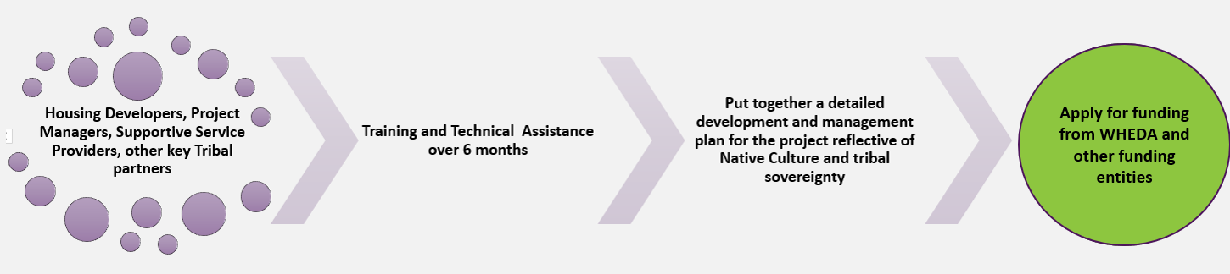

INSTITUTE DELIVERABLES
Upon completion, participants in the institute will have:

- A strong, effective development, property management and service team that leverages the strengths of each team member and has clearly defined roles and responsibilities;
- Improved skills to operate existing supportive housing or develop new projects serving people who experience multiple barriers to housing;
- A detailed, individualized supportive housing plan that includes supportive service and delivery strategies that can be used to apply for funding from multiple sources;
- A Community Support Plan, Tenant Leadership Plan and Property Management Plan;
- A Tenant Selection Plan that ensures alignment with eligibility for tribal, federal, state and local programs providing funding for capital, services, and rental assistance;
- Preliminary project proposal and budgets;
- A powerful network of peers and experts to assist in project development and to trouble-shoot problems;
- An increased understanding of WHEDA financing overall as well as other funding sources designed to increase the supply of supportive housing projects. This includes greater knowledge of how to put together a competitive application for WHEDA’s Housing Tax Credit Program. In the Supportive Housing Set-Aside in WHEDA’s Qualified Allocation Plan, of which a minimum of 25% of the total units must be set aside for chronically homeless individuals;
- The opportunity to apply for early pre-development financing through CSH to use on supportive housing projects planned through the institute; and
- Post-institute technical assistance from CSH.

JOIN US FOR THE INSTITUTE!

HOW TO APPLY

As you prepare to apply for the institute, please keep these points in mind:

INSTITUTE TEAMS

- Ideally, teams would include a developer partner, a supportive service provider partner, and a property management partner. One entity can represent more than one partner. For instance, a Tribal Nation may be the developer and the social service provider.

- PLEASE NOTE: CSH will help you find partners if you do not have one or more of the necessary team partners. You should still apply even if you do not have all the necessary team partners.
  - Developer Partner: The developer leads the process of planning the supportive housing project, including key decisions about the physical structure and site of the project, team members, and funding.
  - Supportive Service Provider: The supportive services provider provides a comprehensive package of supports that help tenants sustain housing stability and meet life goals. These services may be provided by the project’s designated primary service provider or by collaborating organizations. The primary service provider ensures that tenants can access needed services on an ongoing basis.
  - Property Manager: The property manager is responsible for receiving and processing tenant rental applications, receiving rent payments, and ensuring the ongoing physical (facilities or physical plant) upkeep of the housing. In projects that include ongoing ownership of units or a long-term master lease arrangement, the property management staff is typically part of the supportive housing team.
  - Owner: The overall owner of the supportive housing development. Often, this is the developer or Housing Tax Credit equity investor, but it could also be the service provider or (more rarely) the property manager.

- Teams can also include other key tribal staff, non-Native allies, or community stakeholders deemed necessary for successful development of the supportive housing project.

- Teams are also encouraged to incorporate the feedback and experience of current or prospective supportive housing residents into their project. This could be either through direct participation in the team by someone who has lived experience, focus groups with current supportive housing tenants or other existing groups of tenants/community members.

- Each team will designate a team leader.

ATTENDANCE REQUIREMENTS

To be eligible for the institute, ALL team members must be able to commit to attending ALL training sessions and the site visit.

The institute will consist of 15 training days and one site event over six months (approximately 100 hours of training and technical assistance).

INSTITUTE SCHEDULE
The institute will be delivered both in-person and virtually. The schedule is listed below:

May 2023:
- In-Person: Two-day Session from 9 am to 5 pm CST each day (lunch, beverages, and snacks included)
- Location TBD
  - 5/23: Intro to Supportive Housing and institute; Project Concept
  - 5/24: Roles and Partnerships

June 2023:
- Virtual Sessions: from 9 am to 1:30 pm CST each day (lunch break included)
  - 6/21: Project Design
  - 6/22: Project Design and Services Planning
  - 6/23: Services Planning

July 2023:
- Virtual Sessions: from 9 am to 1:30 pm CST each day (lunch break included)
  - 7/19: Building out a budget for your supportive housing project
  - 7/20: Building out a services and operating budget for your project
  - 7/21: Building out a capital budget for your project

August 2023:
- In-Person: Two-day Session from 9 am to 5 pm CST each day (lunch, beverages, and snacks included)
- Location TBD
  - 8/8: Property Management
  - 8/9: Fair Housing
  - *A site visit will also occur on the August 8 or 9*
September 2023:
- Virtual Sessions: from 9 am to 1:30 pm CST each day (lunch break included)
  - 9/13: First Year
  - 9/14: Endorsement
  - 9/15: Finale Presentation Prep

October 2023:
- In-Person: Two-day Session from 9 am to 5 pm CST each day (lunch, beverages, and snacks included)
- Location: WHEDA Headquarters, 908 E. Main St., Ground Floor Training Rooms, Madison, WI 53703
  - 10/4: In Person Meetings with Teams and Presentation Prep. Institute Dinner.
  - 10/5: Institute Finale Presentations (start first thing in morning so team can drive home in afternoon)

TYPES OF PROJECTS THE INSTITUTE WILL REVIEW

The institute will review developments that consist of only supportive housing units and developments that include a mix of affordable and supportive housing units (what is referred to as integrated supportive housing).

Teams will work in the institute to design a project that meets the needs of their community. For each development project designed, the following requirements will apply:

Housing is permanent and affordable (the tenant household ideally pays no more than 30% of its income toward rent).

Tenants hold leases and acceptance of services is not a condition of occupancy. Leases must be held for at least one year;

Housing is based on the Housing First model which includes eviction prevention and harm reduction strategies;

Comprehensive case management services are accessible by tenants where they live and designed to maximize tenant stability and self-sufficiency; and
- The supportive housing development must design tenant screening in a manner that ensures tenants are not screened out for having too little or no income, active or a history of substance use, a criminal record (with exceptions for funder mandated restrictions), or a history of victimization (e.g. domestic violence, sexual assault or abuse).

Proposals to develop emergency shelters, transitional housing, or shared housing such as group homes or shared apartments, will NOT be considered.

INSTITUTE SELECTION PROCESS
For CSH to provide an appropriate level of technical assistance, the Tribal Institute will be limited to no more than 11 teams.

Consideration will be given to the following factors when selecting teams: How the proposed project will increase capacity to create more supportive housing both on and off tribal land;
- Commitment to developing a supportive housing project and full participation in the institute;
- Quality of the response to the application questions; and
- Alignment with the mission and goals of the institute.

APPLICATION INSTRUCTIONS
Application Deadline: Monday, May 1, 2023

Application Submission: Responses must be submitted to wisconsin.institute@csh.org

An email confirmation will be provided as proof of receipt. If you do not receive a confirmation by Tuesday, May 2, please contact wisconsin.institute@csh.org. It is the applicant’s responsibility to confirm receipt of the application.

The Application Review Team (consisting of CSH and representatives from WHEDA) will evaluate all team applications submitted and notify respondents of the selection decision by Friday, May 5, 2023.

All applicants must block off institute session dates, so they are ready to attend the first two-day in-person session on May 23-24, 2023, and every session thereafter. Submission represents a commitment for the team to attend ALL institute sessions.

CSH provided an institute orientation webinar during the WHEDA Conference on September 1, 2021. View the recording.

We will offer a one-hour informational webinar on the Tribal Institute on April 17, 2023 at 12:00 pm CST.

Questions: All questions must be submitted to: wisconsin.institute@csh.org

SUPPORTIVE HOUSING INSTITUTE APPLICATION
Application Deadline: Monday, May 1, 2023
Application Submission: Responses must be submitted to wisconsin.institute@csh.org

TEAM MEMBER INFORMATION
Please provide information for each member of your team. Tribal Supportive Housing Institute teams must consist of at minimum a supportive service provider partner, a housing developer partner, and a property management partner. Applicants may apply without having identified all of their team members. The Corporation for Supportive Housing (CSH) can help identify and pair you with needed partners to complete your team.

Teams can also include other key tribal staff, non-Native allies, and community stakeholders deemed necessary for the successful development of the supportive housing project. Each team must identify a team leader who will take responsibility for managing the team through the development process and serve as the primary contact.

Team Lead and Primary Contact:

NAME:
TITLE:
TRIBAL NATION/ORGANIZATION:
ADDRESS:
CITY, STATE, ZIP CODE:
PHONE:
EMAIL:

Check boxes for those items that apply:

Developer Service Provider
Property Management
Owner
Other:______________________
Team Member 2:

NAME:
TITLE:
TRIBAL NATION/ORGANIZATION:
ADDRESS:
CITY, STATE, ZIP CODE:
PHONE:
EMAIL:

Check boxes for those items that apply:

Developer Service Provider
Property Management
Owner
Other:

Team Member 3:

NAME:
TITLE:
TRIBAL NATION/ORGANIZATION:
ADDRESS:
CITY, STATE, ZIP CODE:
PHONE:
EMAIL:

Check boxes for those items that apply:

Developer Service Provider
Property Management
Owner
Other: ____________________

Team Member 4:

NAME:
TITLE:
TRIBAL NATION/ORGANIZATION:
ADDRESS:
CITY, STATE, ZIP CODE:
PHONE:
EMAIL:

Check boxes for those items that apply:

Developer Service Provider
Property Management
Owner
Other:

Team Member 5 (Please copy and paste the table and check boxes below if your team consists of more than 5 members:

NAME:
TITLE:
TRIBAL NATION/ORGANIZATION:
ADDRESS:
CITY, STATE, ZIP CODE:
PHONE:
EMAIL:

Check boxes for those items that apply:

Peer Support Service Provider
Property Management
Community Partner
Other: _____________
SUPPORTIVE HOUSING PROJECT CONCEPT
We recognize that you may be in the early stages of your supportive housing project, so please share as much as you currently know about your project concept. We understand it may change as you work to refine your project during the institute. Please fill out the following with as much information as you currently know. Feel free to leave sections blank if you don’t know the answers.
Site: Please list up to three (3) potential sites, if you’ve identified them, that you are considering for your project

Address(s) or General Location | Site Control  (Y/N) | New Construction  or Rehab
Design Concept: Please provide estimates of the following, including the anticipated number of permanent supportive housing (PSH) units. For a definition of supportive housing, click here.
Total # of Units
Total # of Buildings
Single Site (100% PSH) or Integrated (specify % PSH)
Unit Type: | PSH | 0- 30% AMI  (Not PSH) | 30- 60% AMI | 60-80% AMI
# of Studio Units
# of 1 BR Units
# of 2 BR Units
# of 3+ BR Units
If unknown, please explain why:
*Integrated refers to partial PSH. Please specify the percent of permanent supportive housing units you are planning in your development as a percentage of total units*

Target Population: If you plan to serve more than one population, please describe which population is primary and why multiple populations were chosen. For example, you might want to target Veterans experiencing homelessness AND community members navigating the challenges of severe mental illness. Or, you might want to target youth exiting foster care who are at risk of experiencing homelessness and who also have been diagnosed with a developmental disability or disabling condition.

Target Population | # of Units

APPLICATION NARRATIVE
Please submit responses to the below questions to the best of your ability.

Project Concept

- Please describe the proposed project concept.

- Please describe the supportive services the project will offer tenants, including services the supportive service partner will provide (both on-site and off-site), description of the services other organizations may provide (both on-site and off-site), and a description of services available to tenants in the community.

- Please describe the proposed property management plan including proposed staffing and on-site hours (i.e. evening, weekend, weekdays).

- Please describe the need for the proposed project, citing local data sources.

Past Experience and Partnerships

- For all the partners on your team, please detail past experience in developing, owning, managing, or providing supportive services in supportive housing.

- If a partner is new to supportive housing, please describe their experience in serving individuals experiencing homelessness, or those who have disabilities such as mental illness, substance abuse, intellectual and/or developmental disabilities.

- For teams including a person with lived experience, please describe your plan to reimburse them for their participation in the project, so that they are funded to participate like other members of the team.

Collaborative Experience

- Please provide a summary of previous collaborations among team organizations. If team members have not worked together previously, describe how each partner was selected and what steps the team has taken to ensure successful collaboration.

- Describe partnerships with non-tribal entities (if applicable).

Disproportionate Impact/Racial Equity

- Describe the demographics of the population in the community where the supportive housing project will reside.

- How is the proposed supportive housing project responding to the identified need in the community? How does responding to that need take into account the demographics of the community?

- Are people with lived experience of homelessness or those who have been, or currently are, tenants in supportive housing included on the project team?

  - If not, how does the team plan to include the expertise of people with lived expertise of homelessness supportive housing tenancy into the design, development and implementation of the proposed project?

COMMITMENT TO THE INSTITUTE
In order for an application to be considered complete, the below must be signed by the team leader.

We commit to:
- Developing a supportive housing project that meets the requirements listed below:
        - Housing is permanent and affordable the tenant household ideally pays no more than 30% of its income toward rent);

        - Tenants hold leases and acceptance of services is not a condition of occupancy;
        - Housing is based on the housing first model which includes eviction prevention and harm reduction strategies;
        - Comprehensive case management services are accessible by tenants where they live and in a manner designed to maximize tenant stability and self-sufficiency; and
        - The supportive housing development must design tenant screening in a manner that ensures tenants are not screened out for having too little or no income, active or a history of substance use, a criminal record (with exceptions for program mandated restrictions), or a history of victimization, e.g., domestic violence, sexual assault or abuse.
- Attending all in-person and virtual training sessions listed above.
- Recognize that CSH is providing the institute and Technical Assistance free of charge to the team and will provide lunch, snacks, and beverages at all in-person events. Teams will be responsible for their own travel, dinner, and staff time expenses to participate in the institute.

Signed: ______________________________________ Date:

